Infosys Springboard Virtual Internship 6.0 Completion Report

Team Details: TeamB< Sanchita kumari, Rachapudi Sai Sree, Seelam Karunya, Nikhil Vijay Kumar Kudipudi, Siddhardha Kaleru , Chidaraboina Nohitha, Nikita Badani>
Batch Number Group 2_Batch- 5
Start date: 13 /10/2025
Name: Sanchita kumari
Internship Duration: 8 Weeks

1. Project Title
InsurAI Corporate Policy Automation and Intelligence System

2. Project Objective
The objective of this project was to design and develop a web-based insurance management portal that enables users to register, log in, view policies, book appointments, and interact seamlessly with agents. The project aimed to improve customer experience and digital accessibility.

3. Project description in detail
The project focuses on the development of a full-stack web application aimed at digitalizing key insurance-related operations using modern web technologies. Traditional insurance systems often rely on manual processes for user management, policy handling, and appointment scheduling, which can lead to inefficiencies and delays. This application addresses these challenges by providing a centralized, secure, and scalable digital platform.
The frontend of the application is developed using React with Vite, ensuring a responsive, interactive, and user-friendly interface. Users can register, authenticate, view available insurance policies, and book appointments through well-structured UI components. The design emphasizes usability and seamless navigation to enhance the overall user experience.
The backend is implemented using Spring Boot, which is responsible for handling business logic, authentication, and communication with the database. RESTful APIs are developed to support operations such as user authentication, admin approval workflows, policy management, and appointment booking. All requests are validated at the backend to ensure data consistency and security.
Data persistence is managed using MySQL, providing reliable and scalable storage. The system follows a structured data model with entities such as User, Policy, Appointment, and Admin to maintain a well-defined workflow. User requests and appointments are routed to the admin dashboard, where administrators can review and approve them. Status updates are reflected in real time on the user interface
Overall, the project demonstrates the practical application of full-stack development concepts and showcases how digital solutions can improve efficiency, transparency, and accessibility in the insurance domain. The implementation reflects an industry-aligned approach and adheres to best practices in software development.

4. Timeline Overview
Week | Activities Planned | Activities Completed
Week 1 | Understand the project and create login and Registration screen | Login and Registration screen created
Week 2 | Learn Springboot and implement it in the project | Started implementing Spring  Boot
Week 3 | Create User ,Admin and Agent Dashboard | User,Admin,Agent dashboard created successfully
Week 4 | Connect springboot to MySQL database | Database created and connected successfully
Week 5 | Learn to fetch data from MySQl | Successfully fetched data from database
Week 6 | Implement Agent Approval by admin | Agent approval by admin implemented
Week 7 | Implement Appointment Scheduling | User can schedule appointments with agents and Admin can approve or reject them.
Week 8 | Work more on appointment scheduling and implement notification system.Final testing and creation of project report. | Notification system implemented.Documentation completed.

5a. Key Milestones
Milestone | Description | Date Achieved
Project Kickoff | Understand the project and plan setup | 16/10/25
Prototype/First Draft | Created frontend UI and draft APIs | 27/10/25
Mid-Term Review | Project 50%complete | 18/11/25
Final Submission | Completed features delivered | 1/12/25
Presentation | Final demo to be presented

5b. Project execution details
The project execution was carried out in a planned and sequential manner by dividing the overall development into backend implementation, frontend development, and system integration. A full-stack development approach was followed, ensuring that each module was developed, tested, and integrated systematically. Version control tools were used throughout the development process to support collaboration and track progress. In
The execution phase started with the design of the system architecture, which included defining application pages, database structure, and user roles. Based on the finalized design, backend development was initiated using Spring Boot. RESTful APIs were created to handle core functionalities such as user authentication, policy management, and application processing. Each API was independently tested using Postman to verify request handling, response accuracy, and error management.
After successful backend validation, the frontend components were developed using React. User interface pages for login, registration, dashboards, and policy listings were implemented to correspond with the backend services. The frontend was then integrated with the backend using axios for API communication. This integration ensured seamless data flow between the client and server.
The admin module was implemented to allow administrators to add and manage insurance policies. These policies were stored in the MySQL database and retrieved dynamically through APIs. On the user side, the policies were displayed as structured cards, enabling users to view and apply for available policies.
Throughout the development lifecycle, regular reviews were conducted to monitor progress and ensure timely completion of tasks. Continuous testing was performed using Postman for backend services and browser developer tools for frontend validation. Input validation, error handling, secure routing, and database connectivity were refined iteratively. Collaborative discussions, debugging sessions, and incremental enhancements contributed to the successful completion of the end-to-end system.

6. Snapshots / Screenshots
These are some of the snapshots and code snippets.
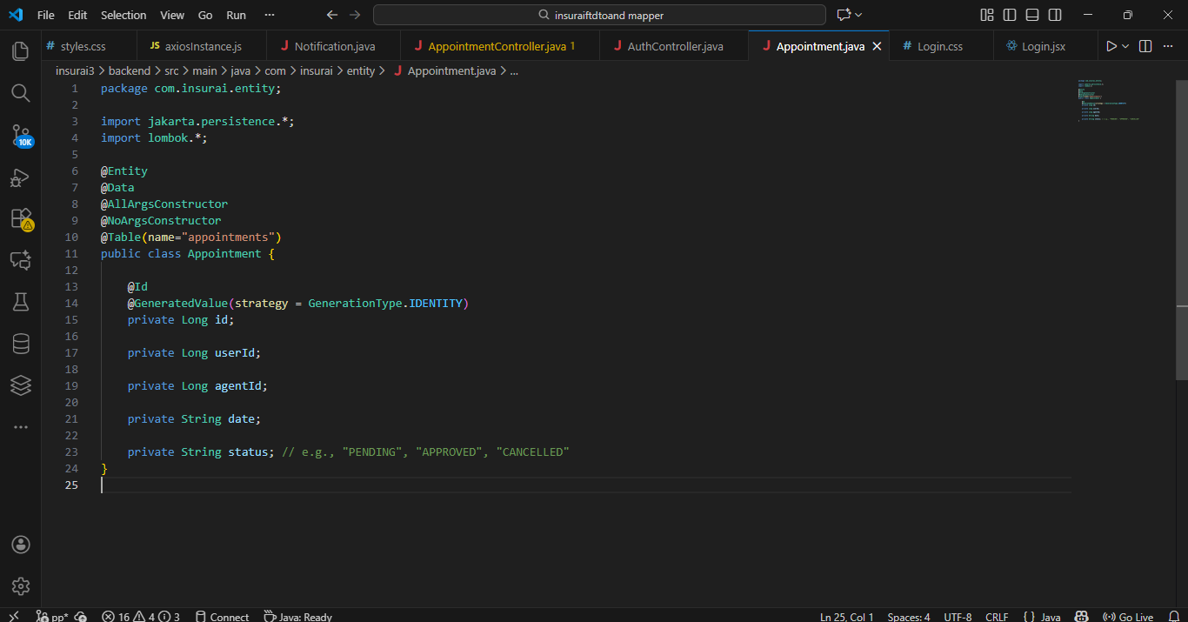
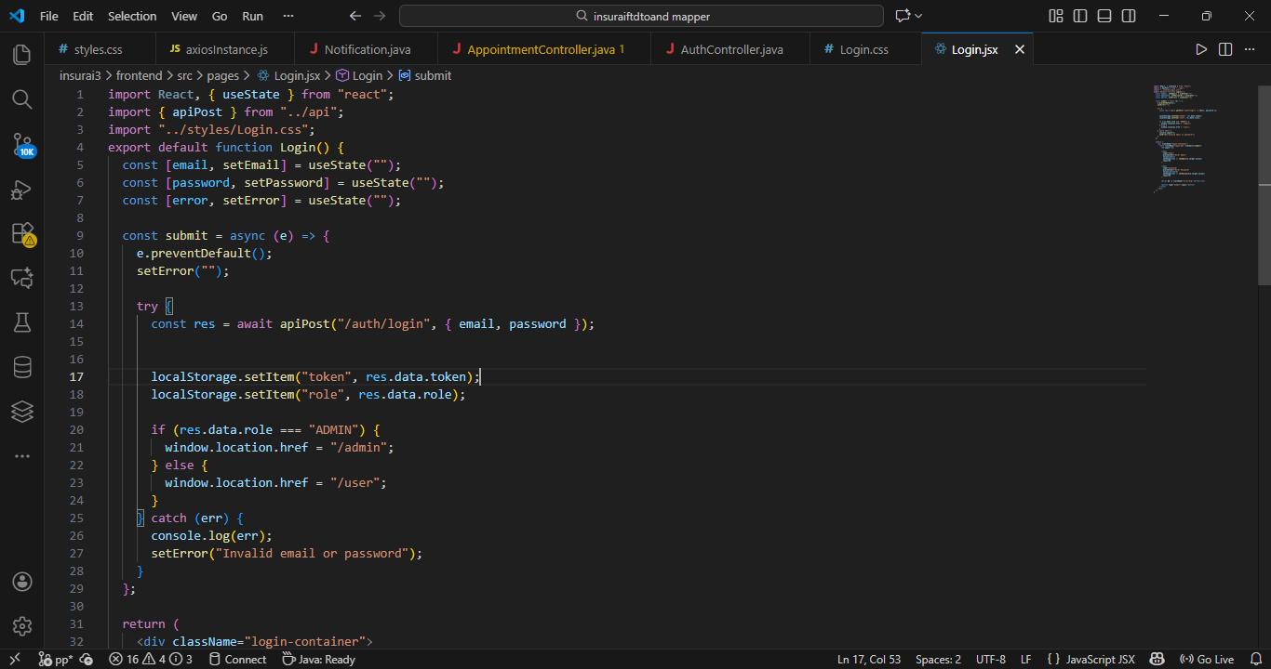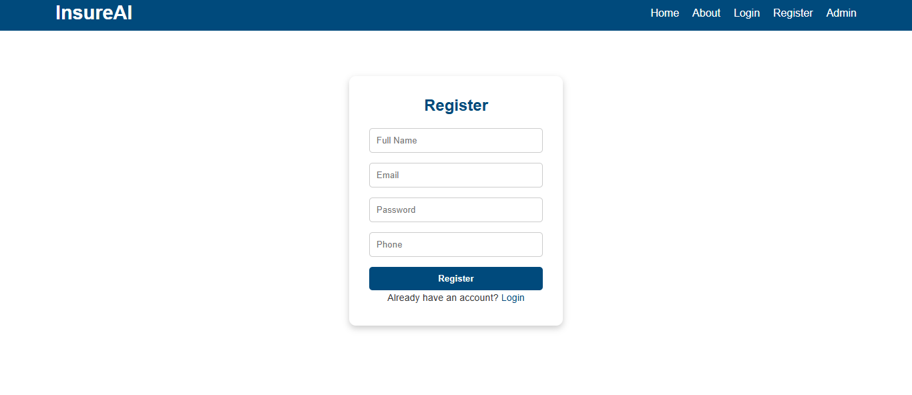
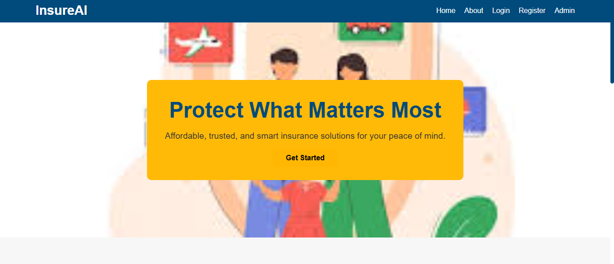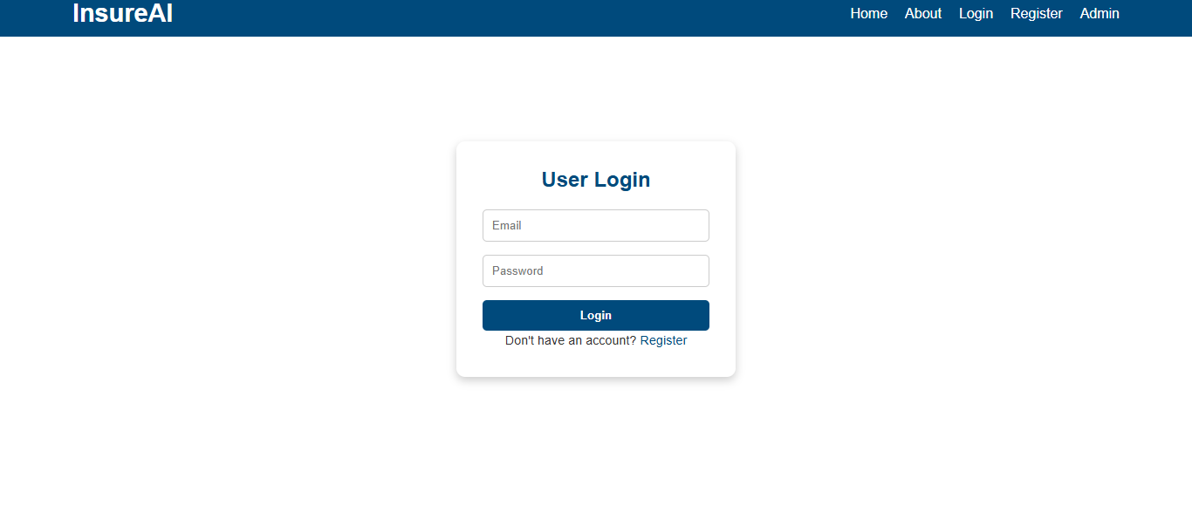

7. Challenges Faced
- Initially understanding Spring Boot backend connections with React was challenging, especially in handling REST APIs.
- We faced data mapping errors due to DTO–Entity conversions and trouble fetching policies dynamically from MySQL.
- Due to exams in between I faced problems in managing time .
- Faced CORS and API fetching issues; resolved using Spring Security configuration.
- Difficulty integrating frontend and backend; fixed by rewriting axios/fetch functions.
- Database table constraints caused errors; corrected schema and seed data.
- Faced network issues on some day in meetings but resolved after trying re login and changing network.
We overcame all these challenges through our mentor guidance and continuous research and learning.Team discussions improved our confidence and performance.

8. Learnings & Skills Acquired
This internship gave us exposure to how enterprise technology ecosystems operate.Throughout the internship we learned both technical skills and soft skills .These includes:
- Full-stack development (React, Spring Boot, MySQL).
- Proper usage of DTOs ,Services and Controllers.
- Working with REST APIs and JSON.
- GitHub version control.
- Improved problem-solving and communication skills along with learning more about teamwork .

9. Testimonials from team
- “This internship helped me gain real-world experience in building production-level applications. I learned how to structure code professionally, work with APIs, and collaborate as part of a technical team.”
- “Working on Insurai allowed us to design a strong and secure backend using Spring Boot and MySQL. We ensured smooth data flow, performance, and reliability across the system.”
- “The Insurai project demonstrates effective mentorship, teamwork, application of full-stack development concepts, and practical implementation of theoretical knowledge in a real-world domain.”
- “Guidance and learning resources provided through Infosys Springboard enabled deeper exploration of modern tools and contributed to the development of analytical and technical problem solving skills”.

10. Conclusion
Overall, the internship provided valuable learning in software development and exposed me to real industry practices. The skills and experience gained will support my future projects and career goals in full-stack development..The Infosys Springboard virtual internship was a highly enriching learning experience.

11. Acknowledgements
I sincerely thank Infosys Springboard for providing this opportunity to learn and work on a real world project. I would like to express my gratitude to my mentor Mr.Senthil Subramanian sir for his consistent guidance,encouragement and constructive feedback throughout the internship. Additionally I acknowledge the dedication and collaborative effort of all team members ,which were essential to the successful completion of this project.
.

